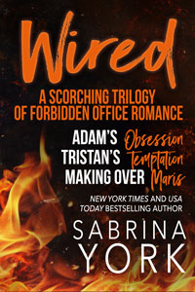
TEN YEARS IN THE COMING!
Sabrina York’s WIRED series is launching in bundle form for it’s 10th Anniversary!
Think a playful 50 Shades in an office where employee hookups are taboo (or, supposed to be), and everyone is a little horny. What could go wrong, right?
THE WIRED SERIES
When Tristan, Adam and Jack started their tech company, they set one firm, unbreakable rule: Thou shalt not hook up with employees. The problem? This company is filled with smart, sexy men and women who are single and hungry to indulge in naughty adventures. And oh, some of the games they get up to… even Adam, Tristan and Jack find it impossible to resist.
- ADAM'S OBSESSION: He discovers his buttoned-up co-worker is his HOT online lover!
- TRISTAN'S TEMPTATION: What's a guy to do when his sexy-as-hell assistant wants to play?
- MAKING OVER MARIS: Years of yearning could be over...if only she'd let him submit!

DISCOUNT PREORDER PRICING
All three award winning novels in one collection! And for less than a buck if you move fast. The preorder price for the digital version is 99 cents. (After release day it will be $6.99). The print book (677 pages of steam) will be available for eager readers at a launch price of $17 (a $7 discount)

RELEASE EXCERPTS AND GIVEAWAYS
For more information on the series, to read excerpts and extended blurbs, as well as information about Sabrina’s tiara giveaway, visit https://sabrinayork.com/wired-series-10th-anniversary-celebration/

SHARE THE WORD!
Please help share the word on social media. Here is a quick and easy share:

******************************************************************************
Playful #50Shades #OfficeRomance from Sabrina York releases May 17th Three book bundle for 99cents (preorders only). https://sabrinayork.com/wired-series-10th-anniversary-celebration/
#FriendsToLovers
#SecretIdentity
#OnlineLover
#BossEmployeeRomance
#NerdRomance
#MakoverRomance
#KindleSelectRomance
#HumorousRomance
#SpankingRomance
#Sugarkink
#DominationRomance
gosh, that elevated quickly!
******************************************************************************

ART

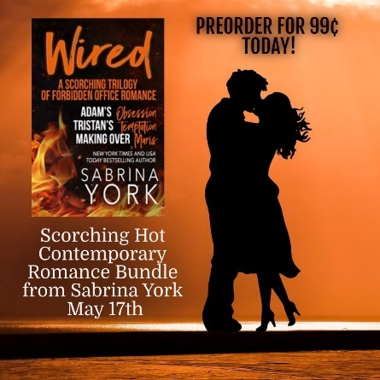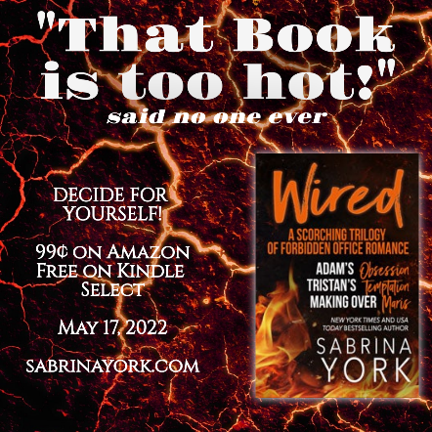
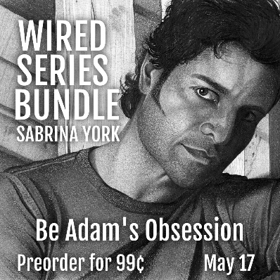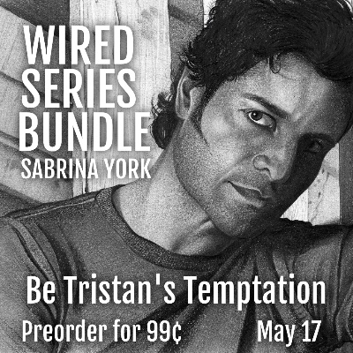

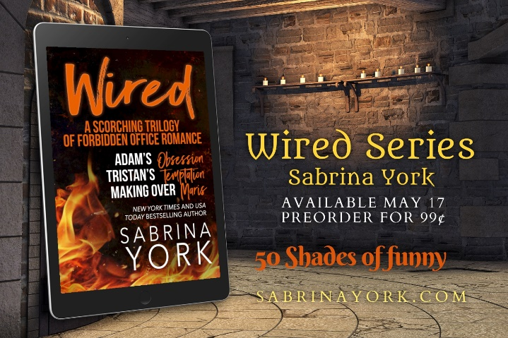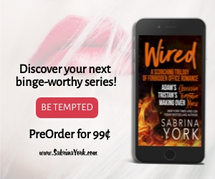

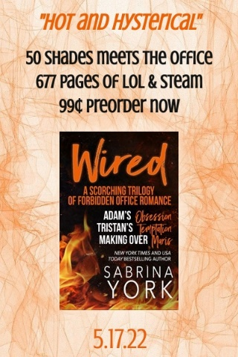
Contact Sabrinayorkhrh at gmail.com if you need a jpg of art or VIDEO TRAILER in MP4

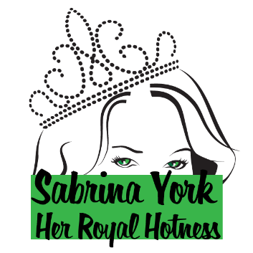
ABOUT SABRINA YORK
Her Royal Hotness, Sabrina York, is the New York Times and USA Today Bestselling author of award-winning hot and humorous romance. Her heroes range from valiant SEALS to sweaty cowboys to hot Highlanders and more.

Her accolades include a RITA nomination for Susana and the Scot, the National Excellence in Romance Fiction Award and more
.
Visit her webpage at www.sabrinayork.com to check out her books, excerpts and tiara giveaways.

For more information, or to connect with Sabrina, visit SabrinaYork.Com

BE A VIP
Never miss a book, contest or opportunity!! Sign up for Sabrina’s VIP Team today!
Get exclusive reads, enter VIP only contests and offers and be the first to know about coming books!

Get a FREE book by signing up for Sabrina’s VIP newsletter at sabrinayork.com/gift (unsubscribe at any time).

CONNECT
Website: SabrinaYork.Com
Instagram
BookBub
Facebook Author Page
Facebook Friend Page
Facebook Chat Group
Twitter: @sabrina_york
Goodreads
Pinterest
Books by Sabrina York
* Indicates it’s hotter than most

CONTEMPORARY ROMANCE ADVENTURES

Wired Series—Office hi-jinx are seriously off limits. Seriously!
Adam’s Obsession, Book 1 *
Tristan’s Temptation, Book 2 *
Making Over Maris, Book 3 *
SERIES BUNDLE *

Stirling Ranch—Small Town Cowboy Romance from Harlequin Special Edition
Accidental Homecoming
Recipe for a Homecoming
The Marine’s Reluctant Return

Stone Hard SEALs—Action Adventure/Military Romance
Stone Hard SEALs—Stone Hard SEALs #1 & 2 (Action-Packed Military Romance Duet)
Guard Dog—Stone Hard SEALs #3 *
Herding Cat—Stone Hard SEALs #4 *
Hot Rod—Stone Hard SEALs 5
Gun Shy—Stone Hard SEALs #6
SERIES BUNDLE *
Want More Military Heroes?
Whipped (Contemporary Romance—also included in the Stone Hard SEALS Bundle as Bonus Material) *
Elite Metal: Warriors Box Set—Action Adventure Romance
Lithium’s Rescue—Elite Ghosts
Sterling’s Seduction—Elite Metal
Cesium’s Capture—Elite Element

Stripped Down Cowboys From Berkley Intermix (And Prequel Novellas)—Steamy Cowboys at a Stud Ranch!
Stud For Hire, Book 1
Cowboy to Command, Book 2
Spurred On, Book 3

Prequel Novellas
The Real McCoy, Prequel Book 1
Come Hell or High Water, Prequel Book 2
Protect and Serve, Prequel Book 3

Tryst Island Series—Steamy Contemporary Romance
Rebound, Book 1
Dragonfly Kisses, Book 2
Smoking Holt, Book 3 *
Heart of Ash, Book 4
Devlin’s Dare, Book 5
Parker’s Passion, Book 6

Stand Alone Contemporary
Heartbreak on a Stick (Contemporary Reunion Romance)
Pool Man (Sexy Vacation Debacle) *
Whipped (Scorching Hilarious Contemporary Romance) *
Fierce (One Night Stand, Contemporary Romance from Decadent Publishing)
Snow Angels (Calendar Men Series Contemporary Romance from Decadent Publishing)

HISTORICAL ROMANCE

James Patterson BookShots—Steamy Regency Highlander
Bedding the Highlander

Noble Passions Series—Steamy Regency (*Think Fifty Shades of #Bridgerton)
Dark Fancy, Book 1 *
Dark Duke, Book 2 *
Brigand, Book 3
Defiant, Book 4
Folly, Book 5 *

Untamed Highlanders—Hot Highlanders from St. Martin’s Press
Hannah and the Highlander, Book 1
Susana and the Scot, Book 2 (RITA Nominee)
Lana and the Laird, Book 3
The Highlander is All That, Book 4
What a Highlander’s Got to Do, Book 5
Say Yes to the Scot Anthology
The Dundragon Time Travel Trilogy
Laird of her Heart, Book 1
Her Hot Highlander Book 2 (Coming*)
His Highland Lass Book 3 (Coming*)
*thank you for your patience!

Waterloo Heroes—Regency Romance
Tarnished Honor, Book 1
Call of the Wild Wind, Book 2

PARANORMAL/FANTASY ROMANCE

Wicked Enchantment—Steamy Romance Fantasy *
Trickery—Steamy Romance Fantasy *

Want Something Different?
SCI/FI SPACE OPERA (writing as SAM YORK)
The Viridian Convict

